**CHAPTER 2**

**Working Principle and Functional**

**Description**

* 1. **Block Diagram**

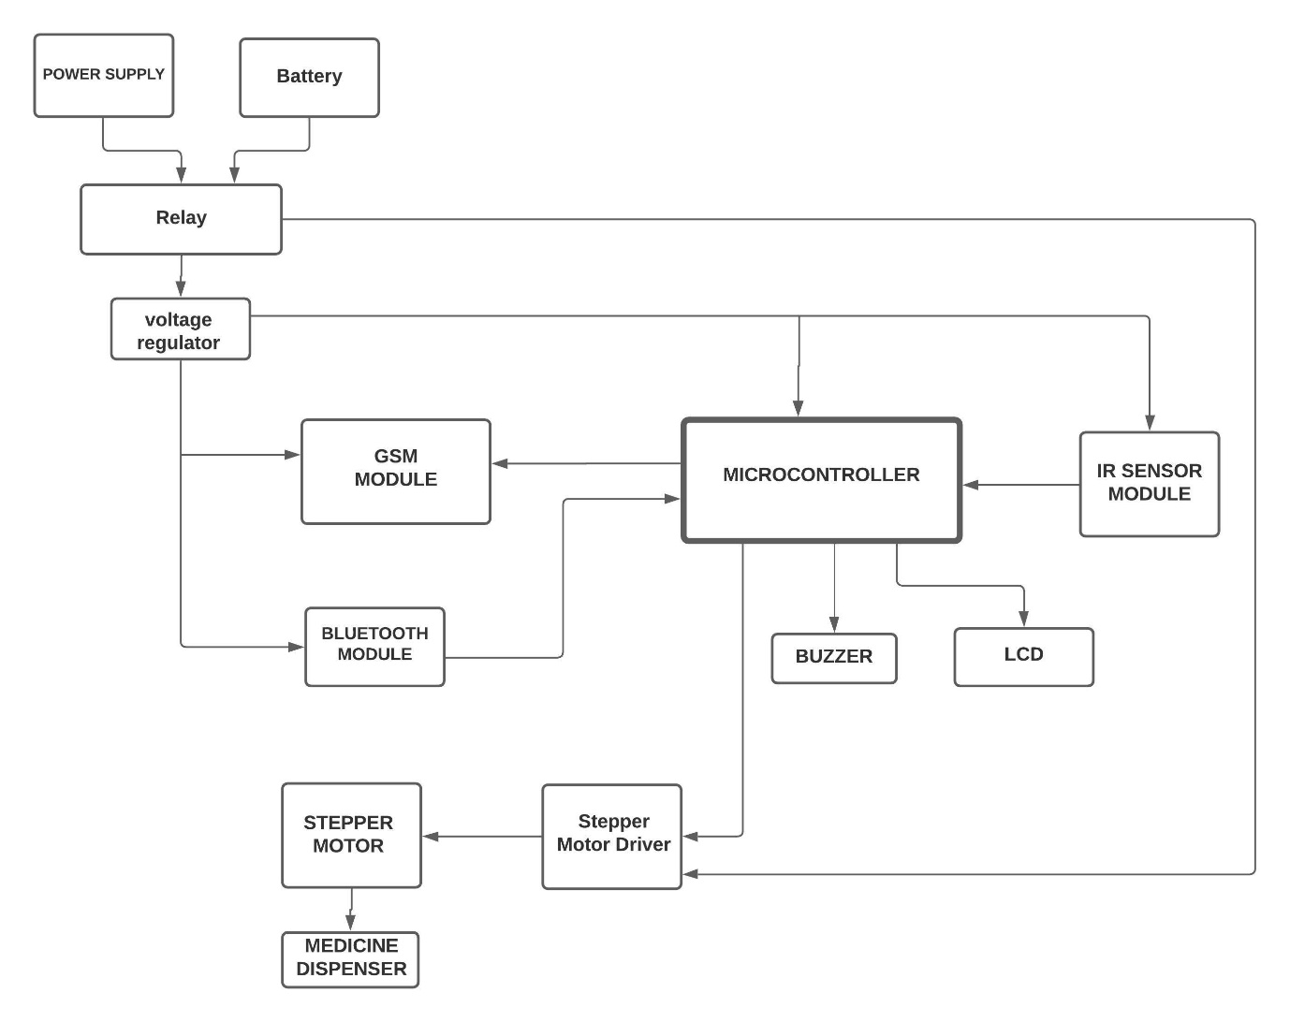

**Figure x Block Diagram**

* 1. **Description of Block Diagram**
     1. **Microcontroller**

This is the main controller of device. And it controls sensors and modules connected to device.

It controls all the important timings of all the operations of the device.

* + 1. **GSM Module**

When the patient fails to take the medicine on the prescribed time even after alerting him/her two times, the GSM module sends a missed call to the caretaker to alert them that medicine is yet not taken.

* + 1. **Bluetooth Module**

Using this Bluetooth module the user can interface the device. The timing schedule of when the medicine is to be dispensed out to the patient is taken using this Bluetooth module.

* + 1. **Stepper Motor**

The stepper motor is used to rotate the medicine compartments of the box at the time of dispensing the medicine.

* + 1. **IR Sensor Module**

The IR sensor module is used to detect if the patient has arrived to collect the medicine at the prescribed time and indicate that the medicine has been taken successfully.

* + 1. **Buzzer**

Buzzer is used to alert the patient at the time of medication.

* + 1. **LCD**

It is used to display the present time. Also it displays the time entered by the user while configuring the medication schedule.

* + 1. **Relay**

Relay is used to switch between the AC mains supply and the Battery during power failure.

* 1. **List of Components**
* AT89s52 Microcontroller
* IR Sensor
* SIM 800c Module
* Stepper Motor (28byj-48)
* Stepper Motor Driver (L293D)
* Buzzer (5V)
* HC-05 Bluetooth Module
* Medicine Dispenser Box
* Battery (12V , 2.5AH)
* Relay (5-12 VDC 10A)
* 11.0592 MHz Crystal Oscillator
* Power Supply (12VDC, 2A)
* 7805 Voltage Regulator IC
  1. **Description of Components**
     1. **At89S52**

In this Project we required a microcontroller which had sufficient pins for interfacing various modules. Also, we needed a microcontroller which supported UART communication Protocol and had built in Timers in it. Enough memory is also required to store the program code as our program code exceeded 4KiB of memory.

Keeping the requirements in mind we decided to use AT89S52 microcontroller of the 8051 Family. This controller has 8 KiB in system programmable memory which is more than enough for our project code. Important specifications of AT89S52 are given below:

**AT89S52**

* 8K Bytes of In-System-Programmable (ISP) Flash Memory
* Operating frequency: 0 Hz to 33MHz
* 256 Bytes of RAM
* Three 16-bit Timers/Counters
* Full Duplex UART serial channel
* Four 8-bit I/O pins

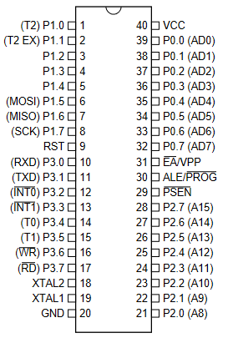

**Figure x Pin Diagram of AT89S52**

**Pin Description:**

|  |  |  |  |
| --- | --- | --- | --- |
| **PIN No.** | **Function of the pin** | | **Pin Name** |
| 1 | external count input to Timer/Counter 2, clock-out. | | P1.0 / T2 |
| 2 | Timer/Counter 2 capture/reload trigger and direction control | | P1.1 / T2EX |
| 3 | I/O pins | | P1.2 |
| 4 | P1.3 |
| 5 | P1.4 |
| 6 | Used for In-System Programming | | P1.5 / MOSI |
| 7 | Used for In-System Programming | | P1.6 / MISO |
| 8 | Used for In-System Programming | | P1.7 / SCK |
| 9 | Resets the controller when high | | RST |
| 10 | Receiver for the serial UART Communication | I/O pins | P3.0 / RXD |
| 11 | Transmitter for the serial UART Communication | P3.1 / TXD |
| 12 | External Interrupt 0 (Active Low) | P3.2 / INT0 |
| 13 | External Interrupt 1 (Active Low) | P3.3 / INT1 |
| 14 | Counter 0 external input | P3.4 / T0 |
| 15 | Counter 1 external input | P3.5/ T1 |
| 16 | external data memory write strobe (Active Low) | P3.6/ WR |
| 17 | external data memory read strobe (Active Low) | P3.7 / RD |
| 18 | Output from the inverting oscillator amplifier | | XTAL2 |
| 19 | Input to the inverting oscillator amplifier and input to the internal clock operating circuit | | XTAL1 |
| 20 | Ground Pin (0 V) | | GND |
| 21 | Higher order Address bits when using external memory | I/O pins | P2.0 / AD8 |
| 22 | P2.1 / AD9 |
| 23 | P2.2 / AD10 |
| 24 | P2.3 / AD11 |
| 25 | P2.4 / AD12 |
| 26 | P2.5/ AD13 |
| 27 | P2.6/ AD14 |
| 28 | P2.7 / AD15 |
| 29 | Program Store Enable; Used as read strobe for external memory | | PSEN |
| 30 | Address Latch Enable | | ALE/PROG |
| 31 | External Access enable; used when using external memory. (For internal memory operation strap it to Vcc) | | EA/VPP |
| 32 | Higher order Address bits when using external memory | I/O pins | P0.0 / AD7 |
| 33 | P0.1 / AD6 |
| 34 | P0.2 / AD5 |
| 35 | P0.3 / AD4 |
| 36 | P0.4 / AD3 |
| 37 | P0.5/ AD2 |
| 38 | P0.6/ AD1 |
| 39 | P0.7 / AD0 |
| 40 | Supply Voltage ( 5V ) | | Vcc |

**Table x Pin Description of AT89S52**

* + 1. **Sim800c GSM module**

The GSM module is used to send a missed call to the caretaker when the patient fails to take the medicine on time.

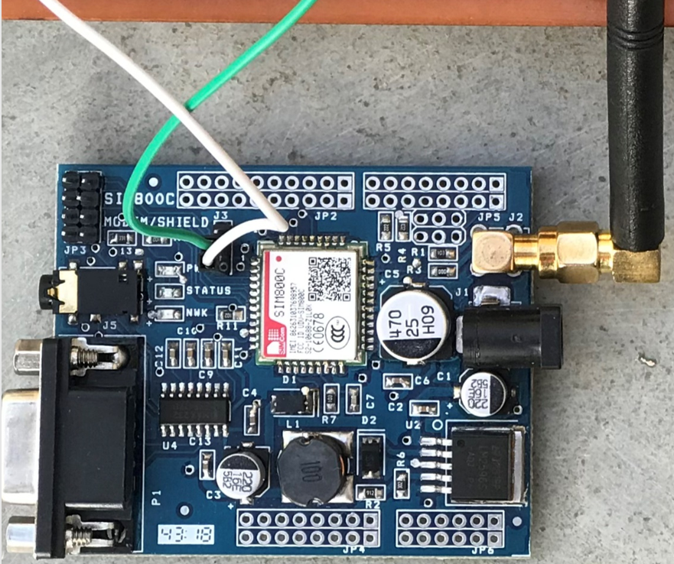

**Figure x Sim800C GSM Module**

The GSM 800C module is equipped with RS-232 connector for use and also supports UART serial communication Protocol. It has fully integrated sim card holder, power supply regulator, audio jack, etc.

It is easy to use with many low-cost microcontrollers as it supports UART communication. SIM800C is a low power quad-band GSM/GPRS module, that works on frequencies GSM850MHz, EGSM900MHz, DCS1800MHz and PCS1900MHz. SIM800H features GPRS multi-slot class 12/ class 10 (optional) and supports the GPRS coding schemes CS-1, CS-2, CS-3 and CS-4.

The module can be configured easily by sending the AT Commands to the module via the Tx pin of Controller connected to the Rx pin of the module. The module has three led indicators namely PWR, Status and NWK.

**PWR** led glows when the module receives the 5V power supply.

**NWK** led indicates if the module is yet registered to the network or not. When registered to a network the led is ON for 64ms and OFF for 3000ms.

**Status** led indicates if the module is ready to function or not.

Features of Sim800c GSM module:

* UART interface for communication with microcontrollers.
* RS-232 interface for connection with computers.
* Baud Rate: 1200 bps to 115200bps.
* Operating Voltage: 3.6 – 4.5V DC.
* Easily controllable using AT commands.
  + 1. **HC-05 Bluetooth Module**

In this project we use the HC-05 Bluetooth module to take the medication schedule data from the user.

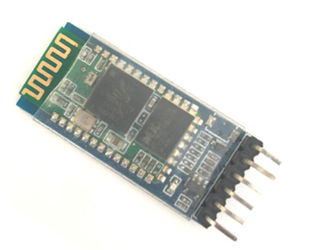

**Figure x HC-05 Bluetooth Module**

HC-05 Bluetooth Modules an easy-to-use Bluetooth SPP (Serial Port Protocol) module, designed for transparent wireless serial connection setup. Its communications via serial communication which makes an easy way to interface with controller or PC. serial port Bluetooth module is fully qualified Bluetooth V2.0+EDR (Enhanced Data Rate) 3Mbps Modulation with complete 2.4GHz radio transceiver and baseband.

This module can be easily configured by sending the AT commands to the HC-05 module from the controller or any other master device.

There is a led on the module that indicates the status of the module. When led blinks once in 2 seconds then it is in command mode. In this mode we send the AT commands to the module.

When led blinks twice every one second it indicates that the connection between the module and other device has been established.

If the led blinks continuously then it indicates that the module is not yet connected to the other device.

The pin description of the module is given below:

|  |  |  |
| --- | --- | --- |
| **PIN No.** | **Pin Name** | **Description** |
| **1** | Enable / Key | This pin is used to toggle between Data Mode (set low) and AT command mode (set high). By default, it is in Data mode |
| **2** | Vcc | Powers the module. Connect to +5V Supply voltage |
| **3** | Ground | Ground pin of module, connect to system ground. |
| **4** | TX | Transmits Serial Data. Everything received via Bluetooth will be given out by this pin as serial data |
| **5** | RX | Receive Serial Data. Every serial data given to this pin will be transmitted via Bluetooth |
| **6** | State | The state pin is connected to on board LED, it can be used as a feedback to check if Bluetooth is working properly. |

**HC-05 Bluetooth Module Specifications:**

* Operating Voltage: 4V to 6V (Typically +5V)
* Operating Current: 30mA
* Range: <100m Typical -80dBm sensitivity
* Up to +4dBm RF transmit power.
* Works with Serial communication (USART) and TTL compatible
* Supported baud rate: 9600,19200,38400,57600,115200,230400,460800.
* Can be easily interfaced with Laptop or Mobile phones with Bluetooth.
* With integrated antenna
  + 1. **28byj-48 Stepper Motor**

28-BYJ48 Stepper Motors are commonly used stepper motors easily available in the market. The motor has a 4-coil unipolar arrangement, and each coil is rated for +5V hence it is relatively easy to control with any basic microcontrollers. These motors have a stride angle of 5.625°/64, this means that the motor will have to make 64 steps to complete one rotation and for every step it will cover a 5.625° hence the level of control is also high. The pull in torque provided by this stepper motor is of 300gf.cm. So, as this motor is small, compact and easy to use we used this motor for our project.

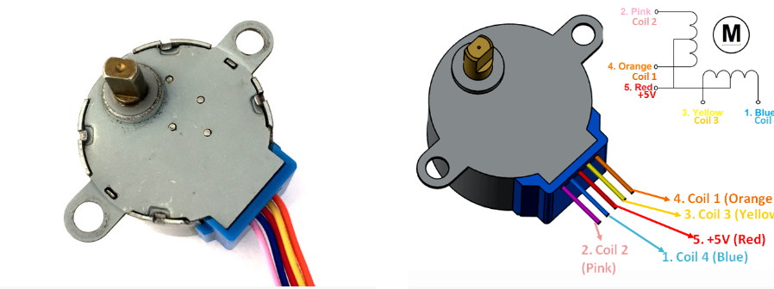

**Figure x 28-BYJ48 Stepper Motor**

**Theory of Operation:**

These stepper motors consume high current and hence a driver IC like the ULN2003 is mandatory. To know how to make this motor rotate we should look into the coil diagram below.

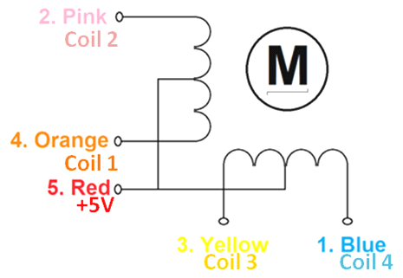

As we can see there are four coils in the motor and one end of all the coil is tied to +5V (Red) and the other ends (Orange, Pink, Yellow and Blue) are taken out as wires. The Red wire is always provided with a constant +5V supply and this +5V will be across (energize) the coil only if the other end of the coil is grounded. A stepper motor can be made to rotate only if the coils are energized (grounded) in a logical sequence. This logical sequence can be programmed using a microcontroller or by designing a digital circuit. The sequence in which each coil should be triggered is shown in the table below. Here “1” represent the coil is held at +5V, since both the ends of coil is at +5V (red and other end) the coil will not be energized. Similarly, “0” represents the coil is held to ground, now one end will be +5V and the other one is grounded so the coil will be energized.

|  |  |  |  |  |  |  |  |  |
| --- | --- | --- | --- | --- | --- | --- | --- | --- |
| **Motor Wire Color** | **Sequence to Rotate in clockwise Direction** | | | | | | | |
| **Step 1** | **Step 2** | **Step 3** | **Step 4** | **Step 5** | **Step 6** | **Step 7** | **Step 8** |
| Orange | 0 | 0 | 1 | 1 | 1 | 1 | 1 | 0 |
| Yellow | 1 | 0 | 0 | 0 | 1 | 1 | 1 | 1 |
| Pink | 1 | 1 | 1 | 0 | 0 | 0 | 1 | 1 |
| Blue | 1 | 1 | 1 | 1 | 1 | 0 | 0 | 0 |
| Red | 1 | 1 | 1 | 1 | 1 | 1 | 1 | 1 |

* + 1. **ULN2003**

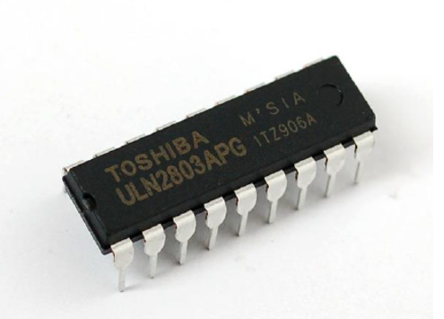

**Figure x. IC ULN2803 Pin Diagram**

The eight NPN Darlington connected transistors in this family of arrays are ideally suited for interfacing between low logic level digital circuitry (such as TTL, CMOS or PMOS/NMOS) and the higher current/voltage requirements of lamps, relays, printer hammers or other similar loads for a broad range of computer, industrial, and consumer applications. All devices feature open–collector outputs and freewheeling clamp diodes for transient suppression.

The ULN2803 is designed to be compatible with standard TTL families while the ULN2804 is optimized for 6 to 15 volt high level CMOS or PMOS.

* + 1. **IR Sensor Module**

The IR sensor module is used to detect if the patient has arrived to collect the medicine at the prescribed time and indicate that the medicine has been taken successfully. This is done by sensing the hand of the patient below the medicine outlet. When patient keeps the hand below the open part the IR sensor detects his/her hand and signals the device that patient has come to take the medicine and then controller takes further action.

* + 1. **Buzzer**

The Buzzer is used to alert the patient at the time of medication if he/she is away from the device. Also, if the patient is unable to find the device the buzzer would help them find it at the time of medication. The buzzer we used in this project is the Piezoelectric Buzzer.

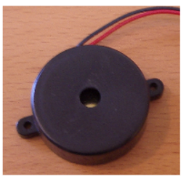

**Figure x Piezoelectric Buzzer**

Buzzer has two pins in it. One is positive and other is negative, when negative pin is grounded and the positive pin is given voltage of around 5-6 V the buzzer makes a beep sound continuously.

**Buzzer Specifications:**

* Rated Voltage: 6V
* Operating Voltage: 4V to 8V
* Rated Current ~< 30mA
* Resonant Frequency ~= 2300 Hz
  + 1. **LM 7805**

In this project we are providing the battery-operated power supply using a 12V DC battery. So, to regulate this 12V dc supply we are using a voltage regulator LM7805 IC to regulate this voltage to constant 5V supply.

This series of fixed-voltage integrated-circuit voltage regulators is designed for a wide

range of applications. These applications include on-card regulation for elimination of

noise and distribution problems associated with single-point regulation. Each of these

regulators can deliver up to 1.5 A of output current.

The internal current-limiting and thermal-shutdown features of these regulators essen-

tially make them immune to overload.

In addition to using as fixed-voltage regulators, these devices can be used with external

components to obtain adjustable output voltages and currents, and also can be used as

the power-pass element in precision regulators.

* + 1. **LCD**

we are using a 16x2 LCD display to display the present time and also we display the medication schedule when the caretaker configures the device.



**Figure x 16x2 LCD Display**

An LCD (Liquid Crystal Display) screen is an electronic display module and has a wide range of applications. A 16x2 LCD display is very basic module and is very commonly used in various devices and circuits. A 16x2 LCD means it can display 16 characters per line and there are 2 such lines. In this LCD each character is displayed in 5x7 pixel matrix. The 16 x 2 intelligent alphanumeric dot matrix display can display 224 different characters and symbols. This LCD has two registers, namely, Command and Data.

The LCD should also be instructed about the Position of the Pixels. Hence it will be a hectic task to handle everything with the help of MCU, hence an Interface IC like HD44780 is used, which is mounted on the backside of the LCD Module itself. The function of this IC is to get the Commands and Data from the MCU and process them to display meaningful information onto our LCD Screen.

**Pin Description of LCD:**

|  |  |  |
| --- | --- | --- |
| Pin No. | Pin Name | Description |
| 1 | Ground | Ground pin of the LCD |
| 2 | Vdd | Supply Voltage (4.7V to 5.3V) |
| 3 | Vee | Contrast setting voltage helps to set the contrast of display |
| 4 | RS (Register select) | Used to select the register LCD for Data or Command. When Low the Command register is selected and when high data register is selected. |
| 5 | Read/ Write | Used to indicate the LCD whether data is being read or written |
| 6 | Enable | Connected to Microcontroller Pin and toggled between 1 and 0 for data acknowledgement |
| 7 | DB0 | 8 bit Data Pins |
| 8 | DB1 |
| 9 | DB2 |
| 10 | DB3 |
| 11 | DB4 |
| 12 | DB5 |
| 13 | DB6 |
| 14 | DB7 |
| 15 | LED + | Backlight Vcc |
| 16 | LED - | Backlight GND |

**Features:**

* Operates at Voltage 4.7V to 5.3V
* Current consumption is 1mA without Backlight.
* Consists of an Alphanumeric Display
* Can work in 4-bit as well as 8-bit mode.
  + 1. **Relay**

In this project we are using a stepper motor. The relay is used to stop the supply of power to the stepper motor driver when it is not needed.

A relay is an electromagnetic switch that is used to turn on and turn off a circuit by a

low power signal, or where several circuits must be controlled by one signal.

We know that most of the high-end industrial application devices have relays for their

effective working.

The main operation of a relay comes in places where only a low-power signal can be

used to control a circuit. It is also used in places where only one signal can be used to

control a lot of circuits.

* + 1. **BC547 BJT**

We have used a buzzer in our project to alert the patient. This buzzer cannot be operated by directly connecting it to the controller pin as the controller cannot supply enough current. So we have used BC547 BJT which is a NPN transistor as a switch.

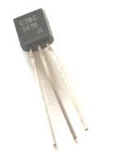

**Figure x BC547 NPN Transistor**

**Specifications:**

* Base Current is 5mA (max)
* DC current gain between 110 to 800
* Bipolar NPN Transistor
* Continuous Collector current (Ic) = 100mA (max)